> describe(hotels.df)

vars n mean sd median trimmed mad

CityName\* 1 13232 18.07 11.72 16 17.29 11.86

Population 2 13232 4416836.87 4258386.00 3046163 4040816.22 3846498.95

CityRank 3 13232 14.83 13.51 9 13.30 11.86

IsMetroCity 4 13232 0.28 0.45 0 0.23 0.00

IsTouristDestination 5 13232 0.70 0.46 1 0.75 0.00

IsWeekend 6 13232 0.62 0.48 1 0.65 0.00

IsNewYearEve 7 13232 0.12 0.33 0 0.03 0.00

Date\* 8 13232 14.30 2.69 14 14.39 2.97

HotelName\* 9 13232 841.19 488.16 827 841.18 641.97

RoomRent 10 13232 5473.99 7333.12 4000 4383.33 2653.85

StarRating 11 13232 3.46 0.76 3 3.40 0.74

Airport 12 13232 21.16 22.76 15 16.39 11.12

HotelAddress\* 13 13232 1202.53 582.17 1261 1233.25 668.65

HotelPincode 14 13232 397430.26 259837.50 395003 388540.47 257975.37

HotelDescription\* 15 13224 581.34 363.26 567 575.37 472.95

FreeWifi 16 13232 0.93 0.26 1 1.00 0.00

FreeBreakfast 17 13232 0.65 0.48 1 0.69 0.00

HotelCapacity 18 13232 62.51 76.66 34 46.03 28.17

HasSwimmingPool 19 13232 0.36 0.48 0 0.32 0.00

min max range skew kurtosis se

CityName\* 1.0 42 41.0 0.48 -0.88 0.10

Population 8096.0 12442373 12434277.0 0.68 -1.08 37019.65

CityRank 0.0 44 44.0 0.69 -0.76 0.12

IsMetroCity 0.0 1 1.0 0.96 -1.08 0.00

IsTouristDestination 0.0 1 1.0 -0.86 -1.26 0.00

IsWeekend 0.0 1 1.0 -0.51 -1.74 0.00

IsNewYearEve 0.0 1 1.0 2.28 3.18 0.00

Date\* 1.0 20 19.0 -0.77 1.92 0.02

HotelName\* 1.0 1670 1669.0 0.01 -1.25 4.24

RoomRent 299.0 322500 322201.0 16.75 582.06 63.75

StarRating 0.0 5 5.0 0.48 0.25 0.01

Airport 0.2 124 123.8 2.73 7.89 0.20

HotelAddress\* 1.0 2108 2107.0 -0.37 -0.88 5.06

HotelPincode 100025.0 7000157 6900132.0 9.99 249.76 2258.86

HotelDescription\* 1.0 1226 1225.0 0.11 -1.25 3.16

FreeWifi 0.0 1 1.0 -3.25 8.57 0.00

FreeBreakfast 0.0 1 1.0 -0.62 -1.61 0.00

HotelCapacity 0.0 600 600.0 2.95 11.39 0.67

HasSwimmingPool 0.0 1 1.0 0.60 -1.64 0.00

> boxplot(RoomRent, main="Boxplot of RoomRent", xlab="RoomRent", horizontal = TRUE)

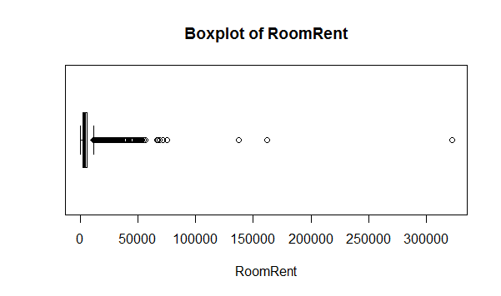

> table(IsWeekend)

IsWeekend

0 1

4991 8241

> table(IsNewYearEve)

IsNewYearEve

0 1

11586 1646

> boxplot(HotelCapacity, main="Boxplot of HotelCapacity", xlab="HotelCapacity", horizontal = TRUE)

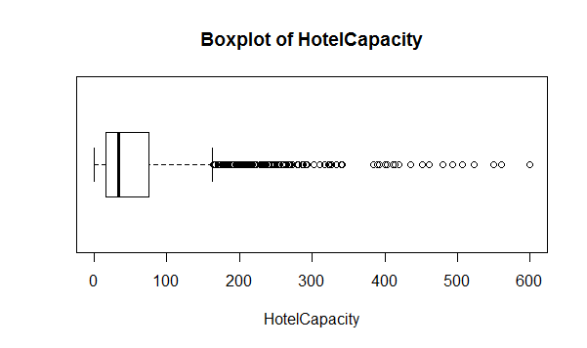

> scatterplot(IsWeekend, RoomRent, main="RoomRent vs Weekend", xlab="1 refers to weekend", ylab="RoomRent")

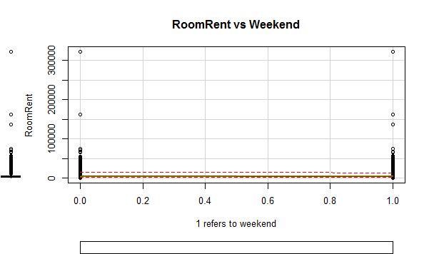

> scatterplot(IsNewYearEve, RoomRent, main="RoomRent vs Newyeareve", xlab = "1 refers to Newyeareve", ylab = "RoomRent")

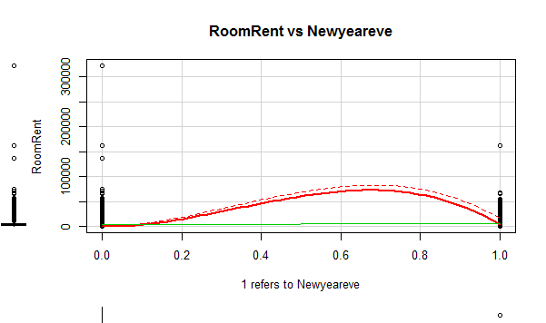

> scatterplot(HotelCapacity, RoomRent, main="RoomRent vs HotelCapacity", xlab = "HotelCapacity", ylab = "RoomRent")

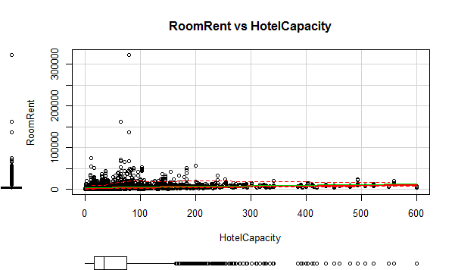

> corrgram(hotels.df[,c(6,7,10,18)], order=TRUE,

+ main="Hotel RoomRent Pricing",

+ lower.panel=panel.pts, upper.panel=panel.pie,

+ diag.panel=panel.minmax, text.panel=panel.txt)

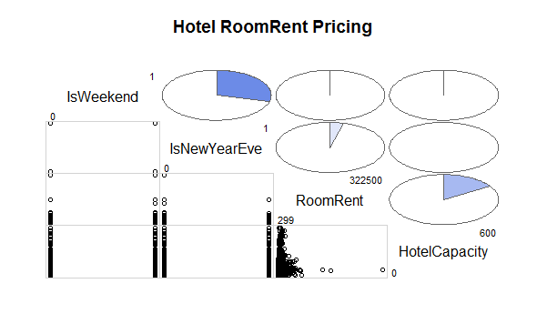

> cov(hotels.df[,c(6,7,10,18)])

IsWeekend IsNewYearEve RoomRent HotelCapacity

IsWeekend 0.2349359 0.04677330 1.627952e+01 2.343426e-01

IsNewYearEve 0.0467733 0.10892942 9.315860e+01 3.422592e-02

RoomRent 16.2795150 93.15859986 5.377460e+07 8.875341e+04

HotelCapacity 0.2343426 0.03422592 8.875341e+04 5.877268e+03